Aliza Shahzad

Module A.2 Level 0 Answers

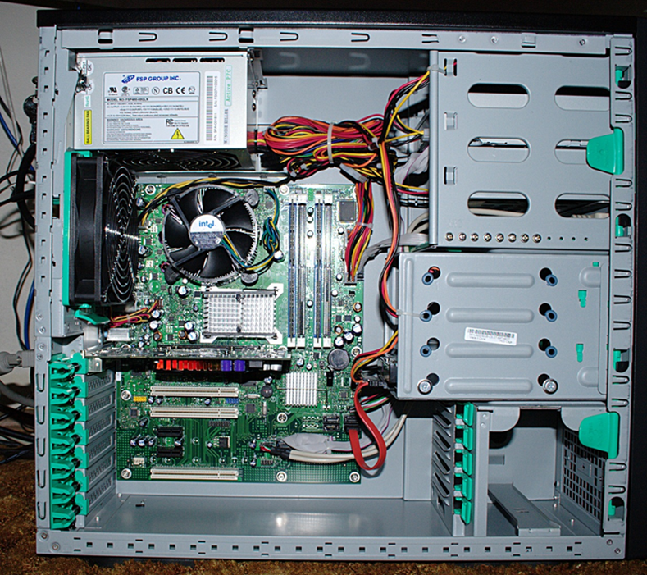

Motherboard

Power Supply Unit

Random Access Memory

(RAM)

Heat Sink/Fan

Optical Drive

Expansion Card

Source:

https://www.thinglink.com/scene/751130111079612417

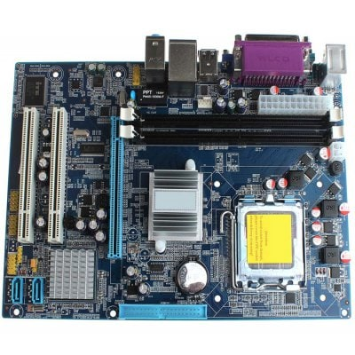

BIOS

SATA

South Bridge

IDE

AGP

PCI

North Bridge

Processor Socket

RAM Memory

Ports

Source: https://turbofuture.com/computers/the-motherboard-components

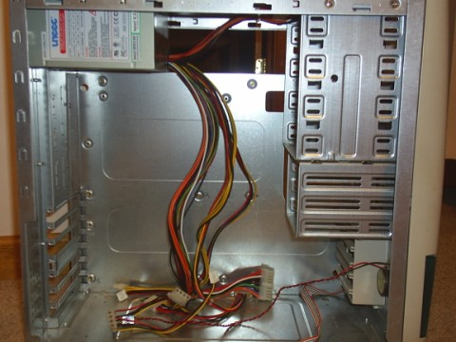

Power Supply Cables

Motherboard

Screw

Holes

Power Supply

Hard Drive Tray

Floppy Drive Tray

CD/DVD Drive Tray

Motherboard is placed here

Motherboard

Cables